- Open your Windows or Linux system, use the command line to assign a static IPv6 address to your primary network adapter, and verify the configuration using ipconfig (Windows) or ifconfig/ip (Linux).
ANS:
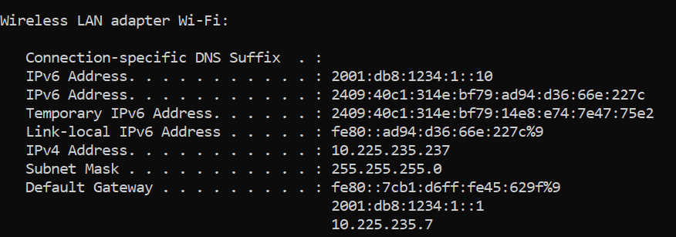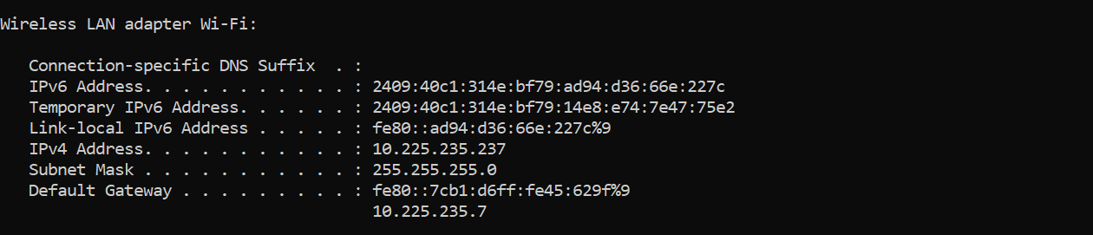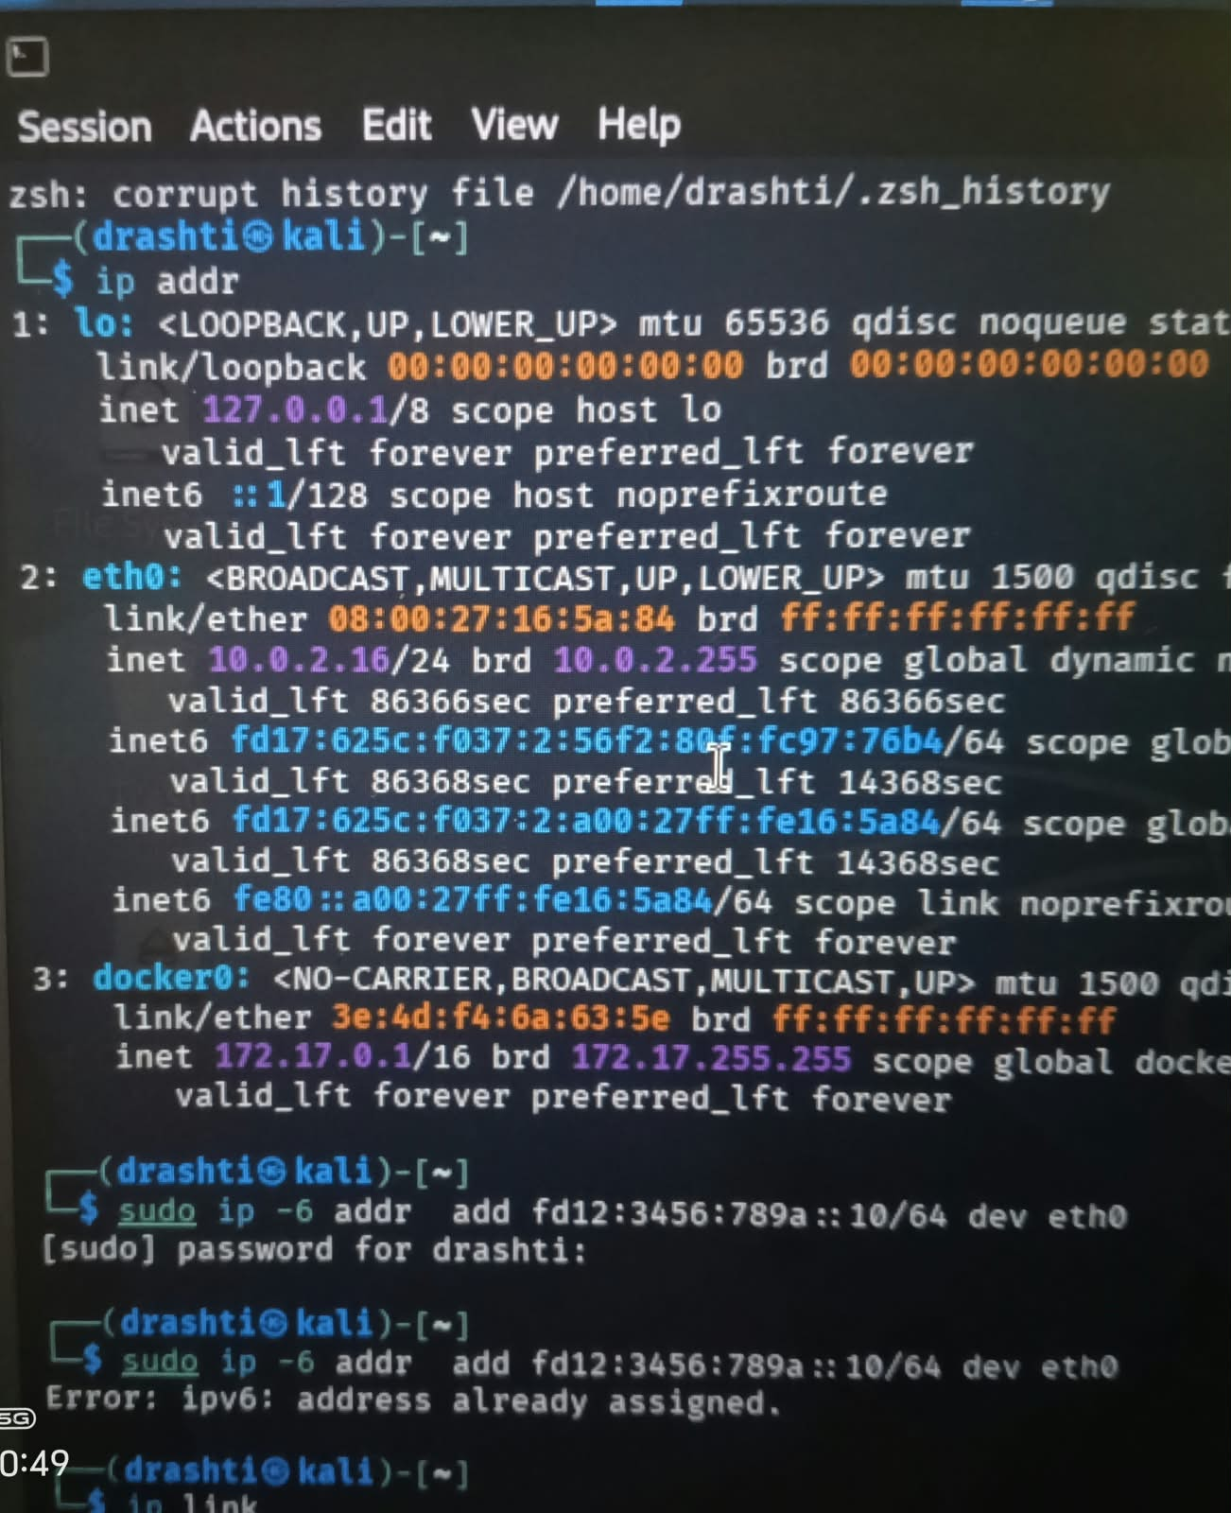 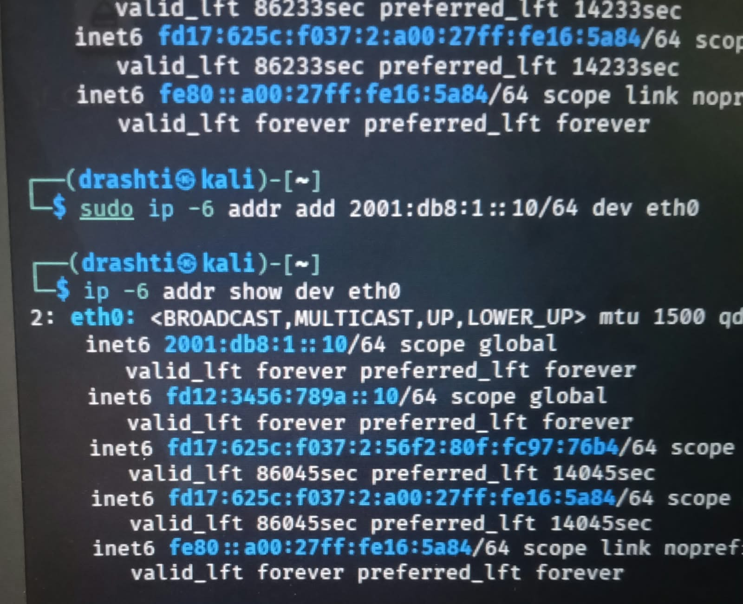2. Configure a unique local IPv6 address (starting with 'fd') on your system and confirm connectivity by pinging another device on your LAN that also has a unique local IPv6 address.<br><br><em><strong>Hint:</strong> Use the ping6 or ping -6 command for IPv6 testing.</em>
ANS:
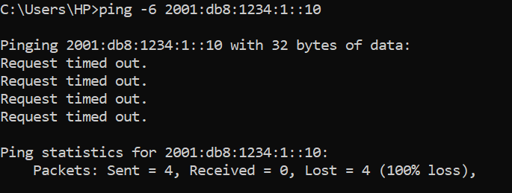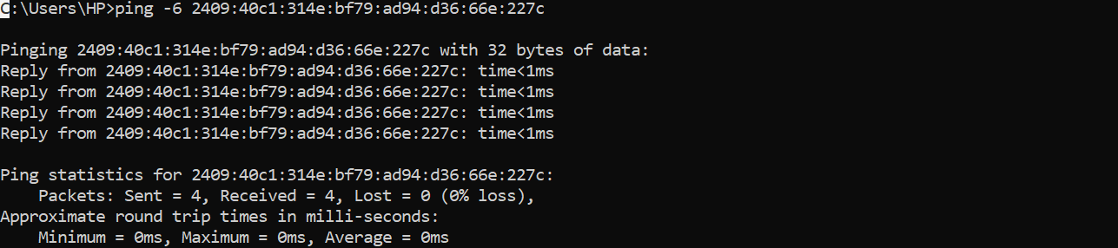
3.
Set up a temporary IPv6 address on your system and check if it changes after a reboot or network disconnect/reconnect.<br><br><em><strong>Constraint:</strong> Document the steps and the observed address behavior in a text file.</em>
ANS:
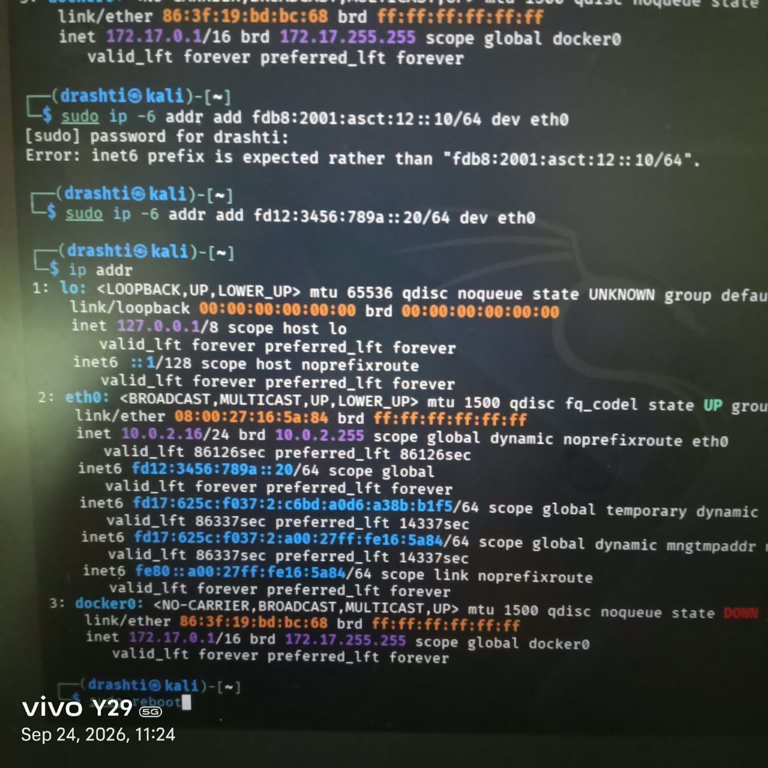
After reboot
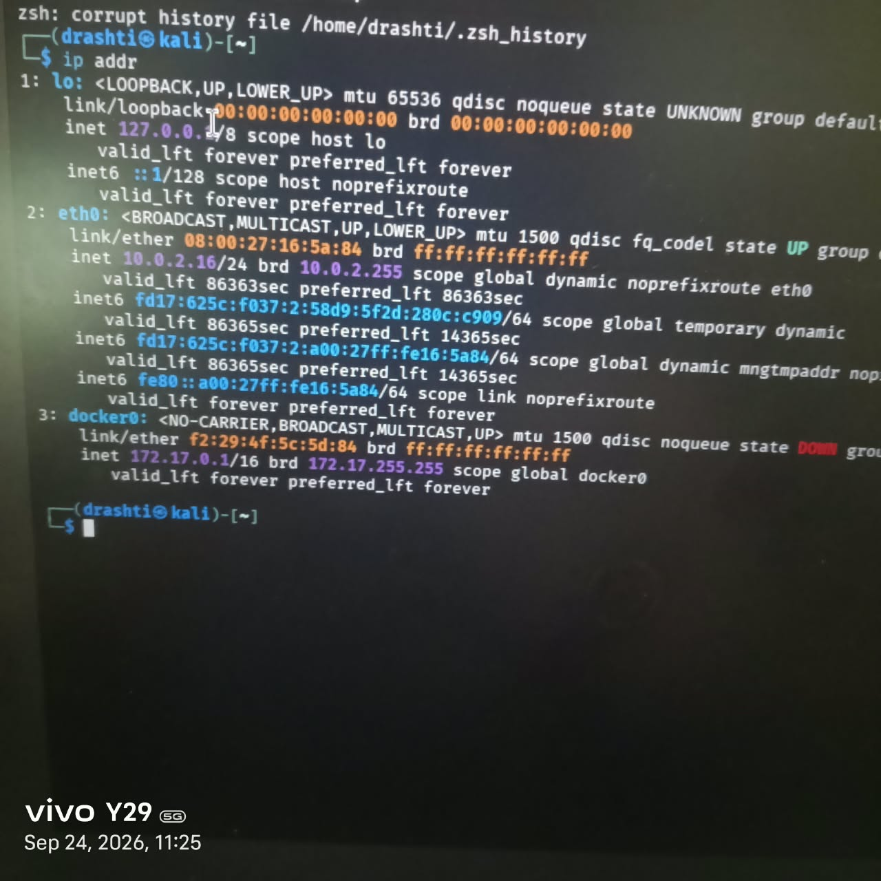
4. Simulate a Zomato-style search: Write a small script (any language) that stores an array of restaurant names and their IPv6 addresses, then allows the user to input a partial name and returns the matching restaurant's IPv6 address.
ANS:
restaurants = {
"Dominos": "2001:db8:1::10",
"Pizza Palace": "2001:db8:2::20",
"Punjabi Tadka": "2001:db8:3::30",
"South Spice": "2001:db8:4::40"
}

search = input("Enter restaurant name: ")

for name, ipv6 in restaurants.items():
if search.lower() in name.lower():
print("Restaurant:", name)
print("IPv6 Address:", ipv6)
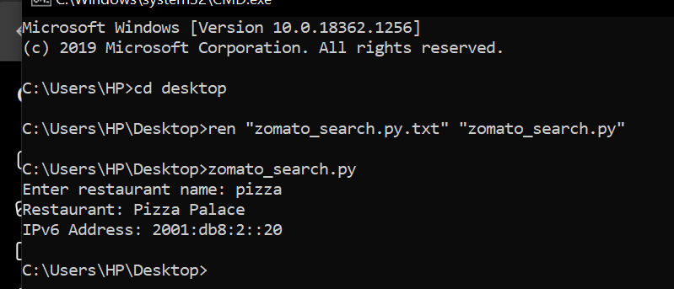
5. Use ChatGPT or Copilot to generate a sample IPv6 subnetting scenario (with at least 3 subnets), and then manually assign a valid IPv6 address from one of those subnets to your system. Paste the AI-generated scenario and your configuration steps in a text file.
ANS:
Base Network: 2001:db8:1234::/48
- HR Department: 2001:db8:1234:1::/64
- IT Department: 2001:db8:1234:2::/64
- Accounts Department: 2001:db8:1234:3::/64
IPv6 Address: 2001:db8:1234:1::10/64
Configuration Steps
- Open Command Prompt as Administrator.
- Check the network adapter name.
- Select the primary network adapter.
- Assign the IPv6 address 2001:db8:1234:1::10/64.
- Verify the configuration using ipconfig.
- Confirm that the assigned IPv6 address is displayed correctly.

